1. Even though we have defined most of the info in out OpenAPI Specification Doc but some consumers may want more details about APIs, Business, Product etc which cannot be described inside the OpenAPI Doc.
2. 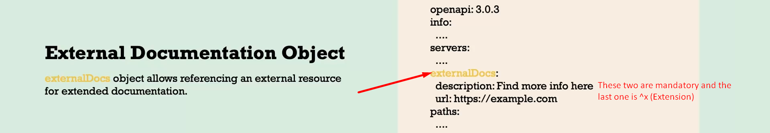
3. 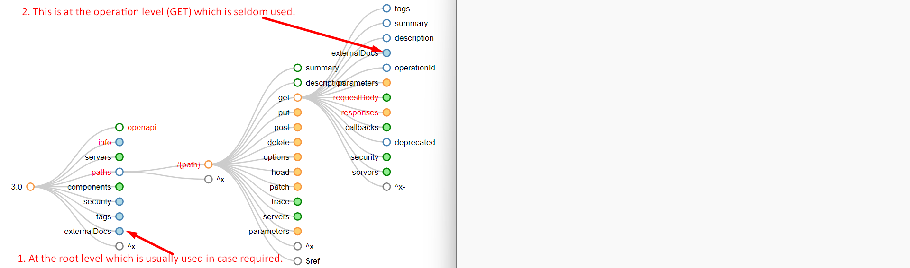
4. <https://github.com/eazybytes/openapi/tree/main/openapi-yaml-examples>
   1. External Doc.
   2. OpenAPI Extension.
   3. OperationId field.
   4. deprecated field.